**Lab 6: *Accounts, Accounts Everywhere* (2%)**

**Name: Khai Phan Student Number: 100901164**

**Results**

**Basic 1:**

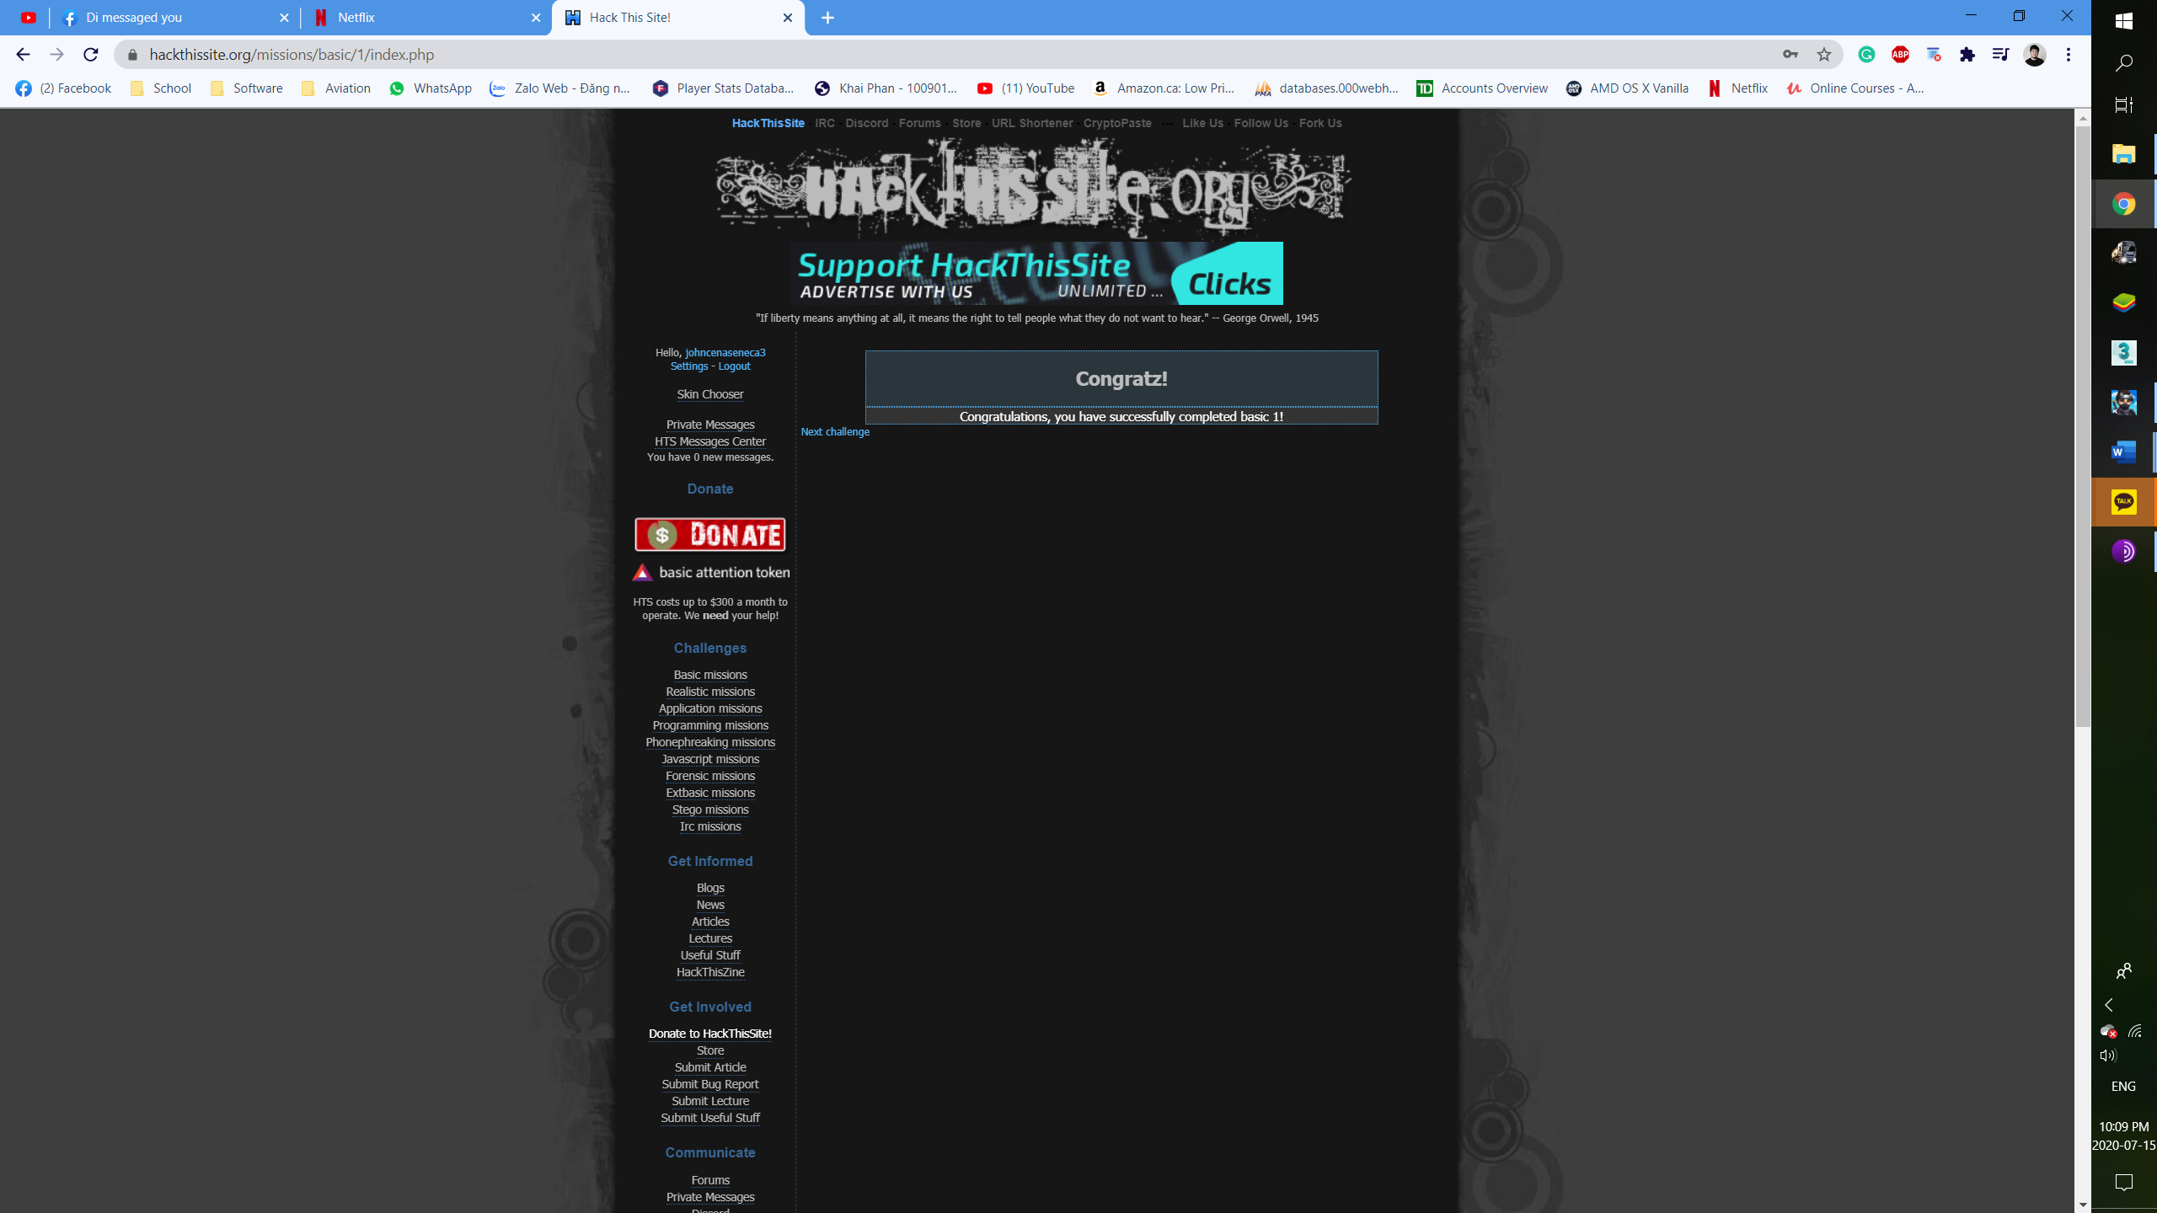

**Basic 2:**

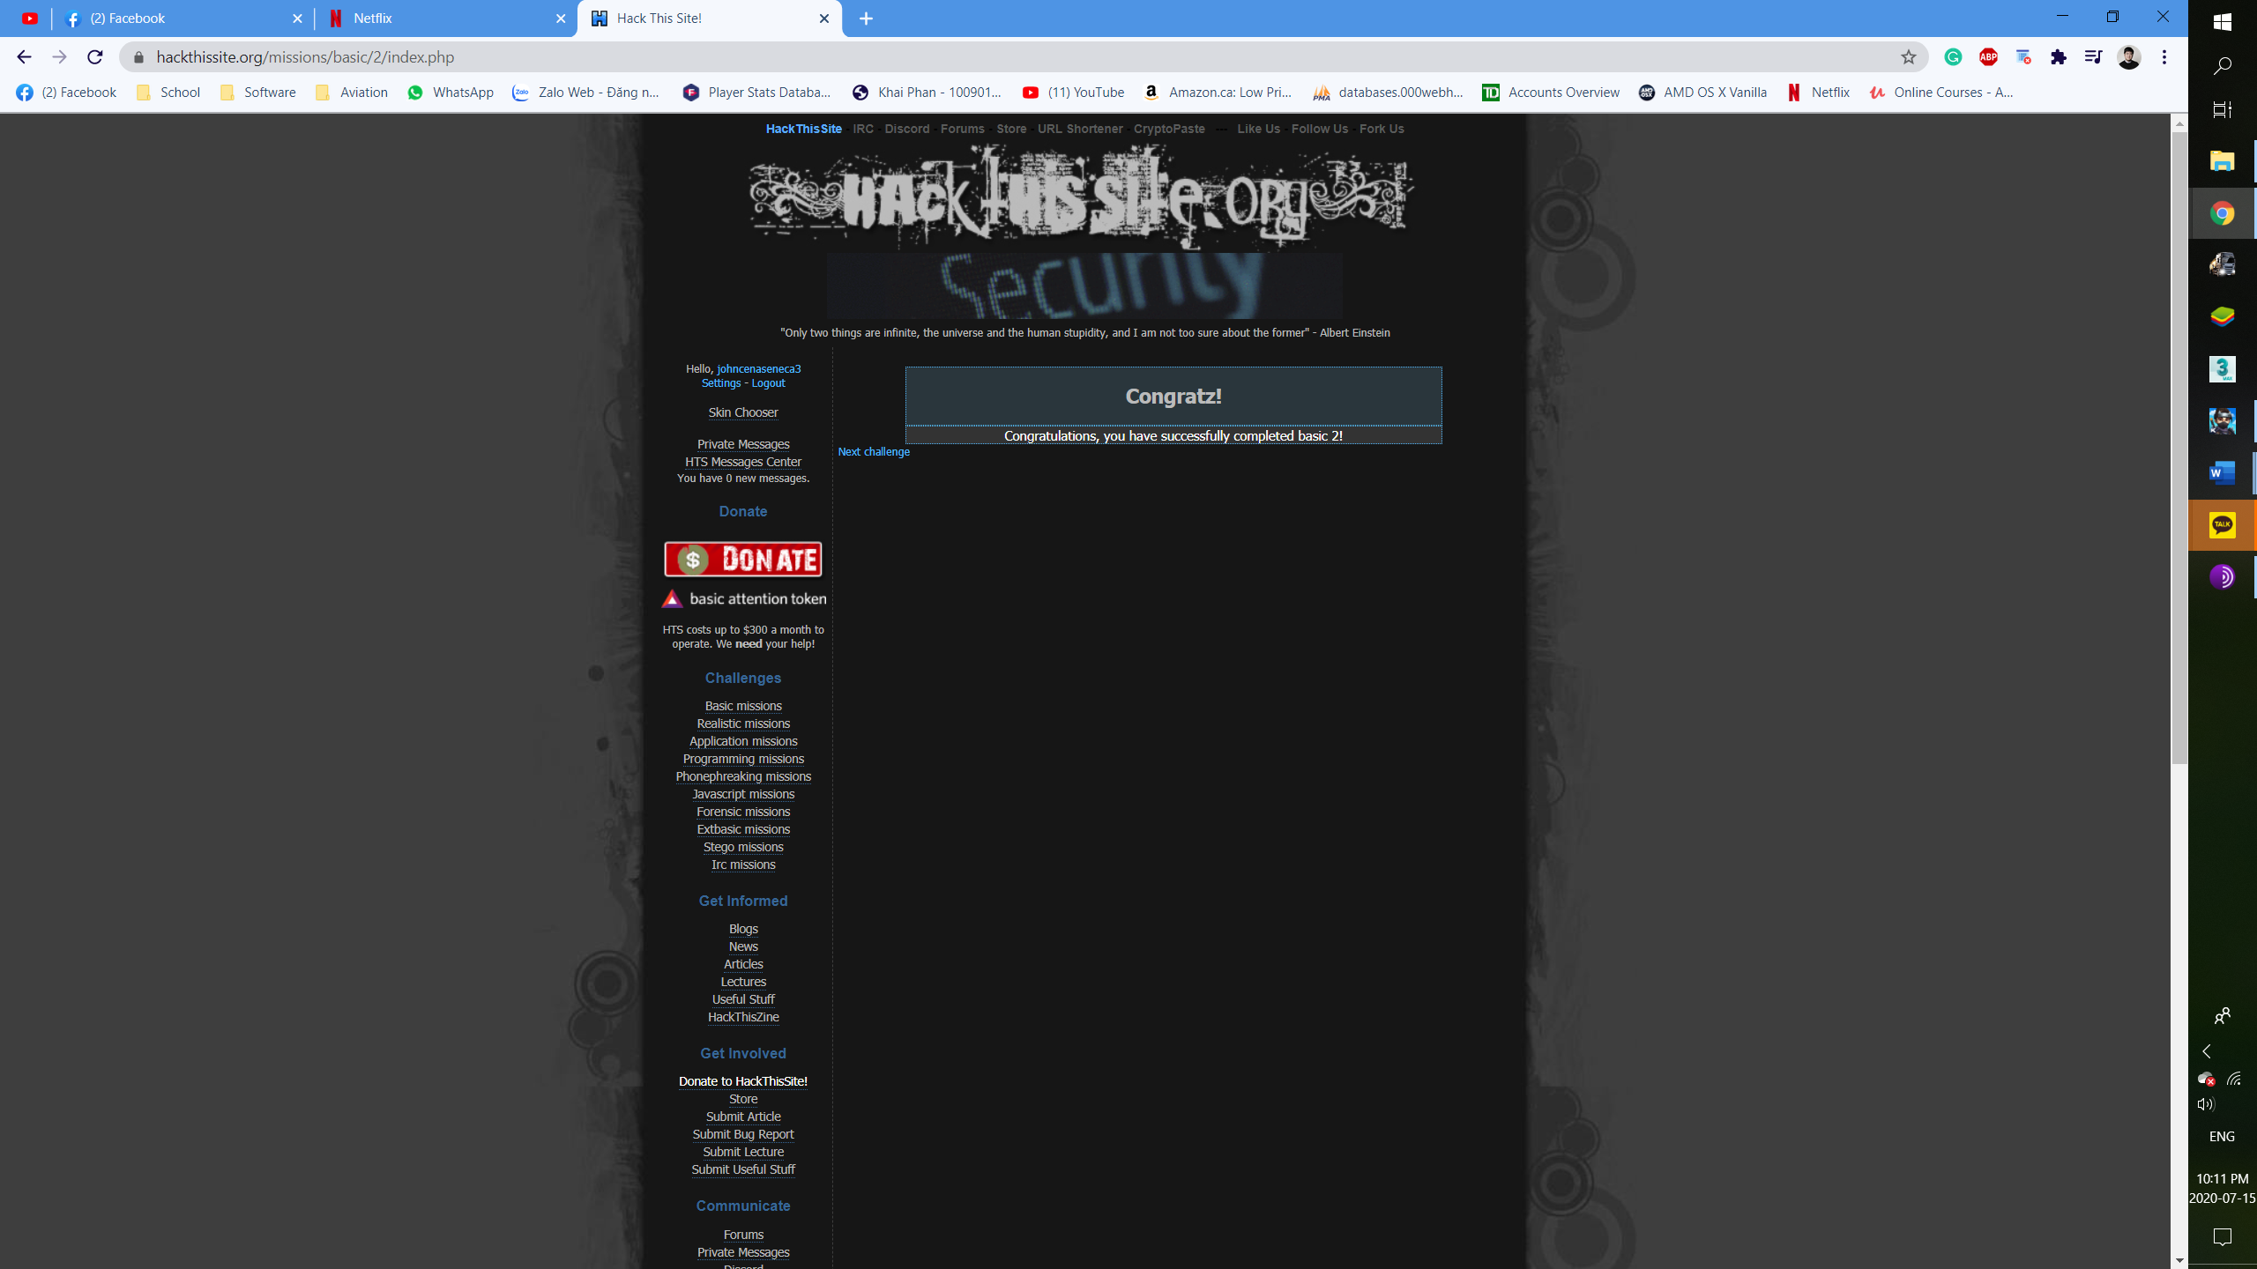

**Basic 3:**

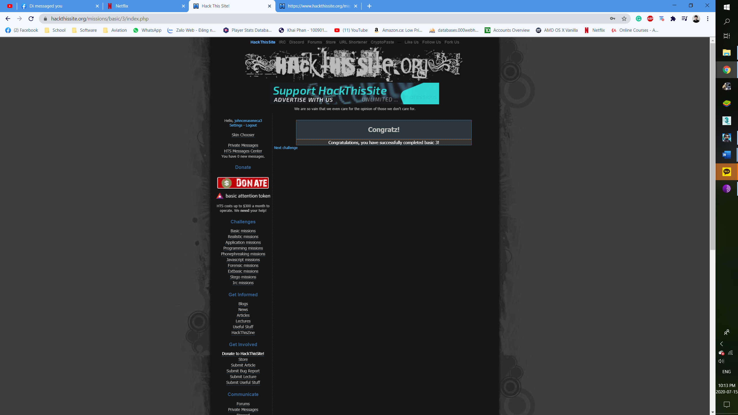

***Basic 4:***

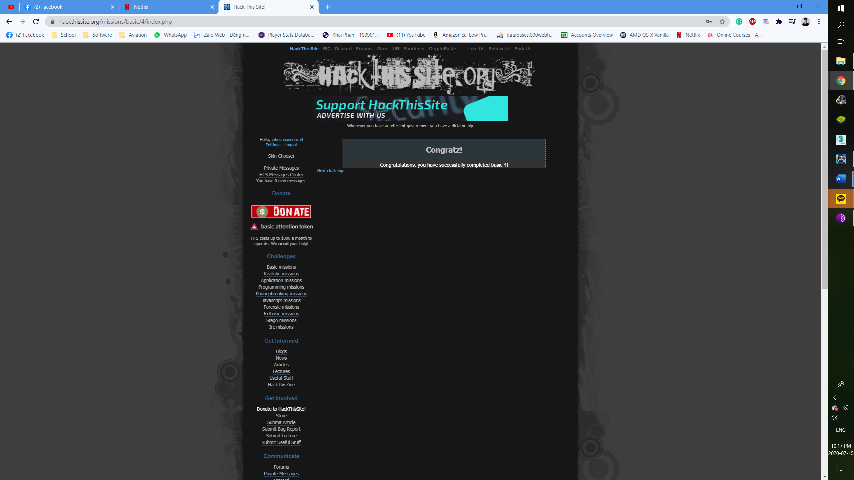

***Basic 5:***

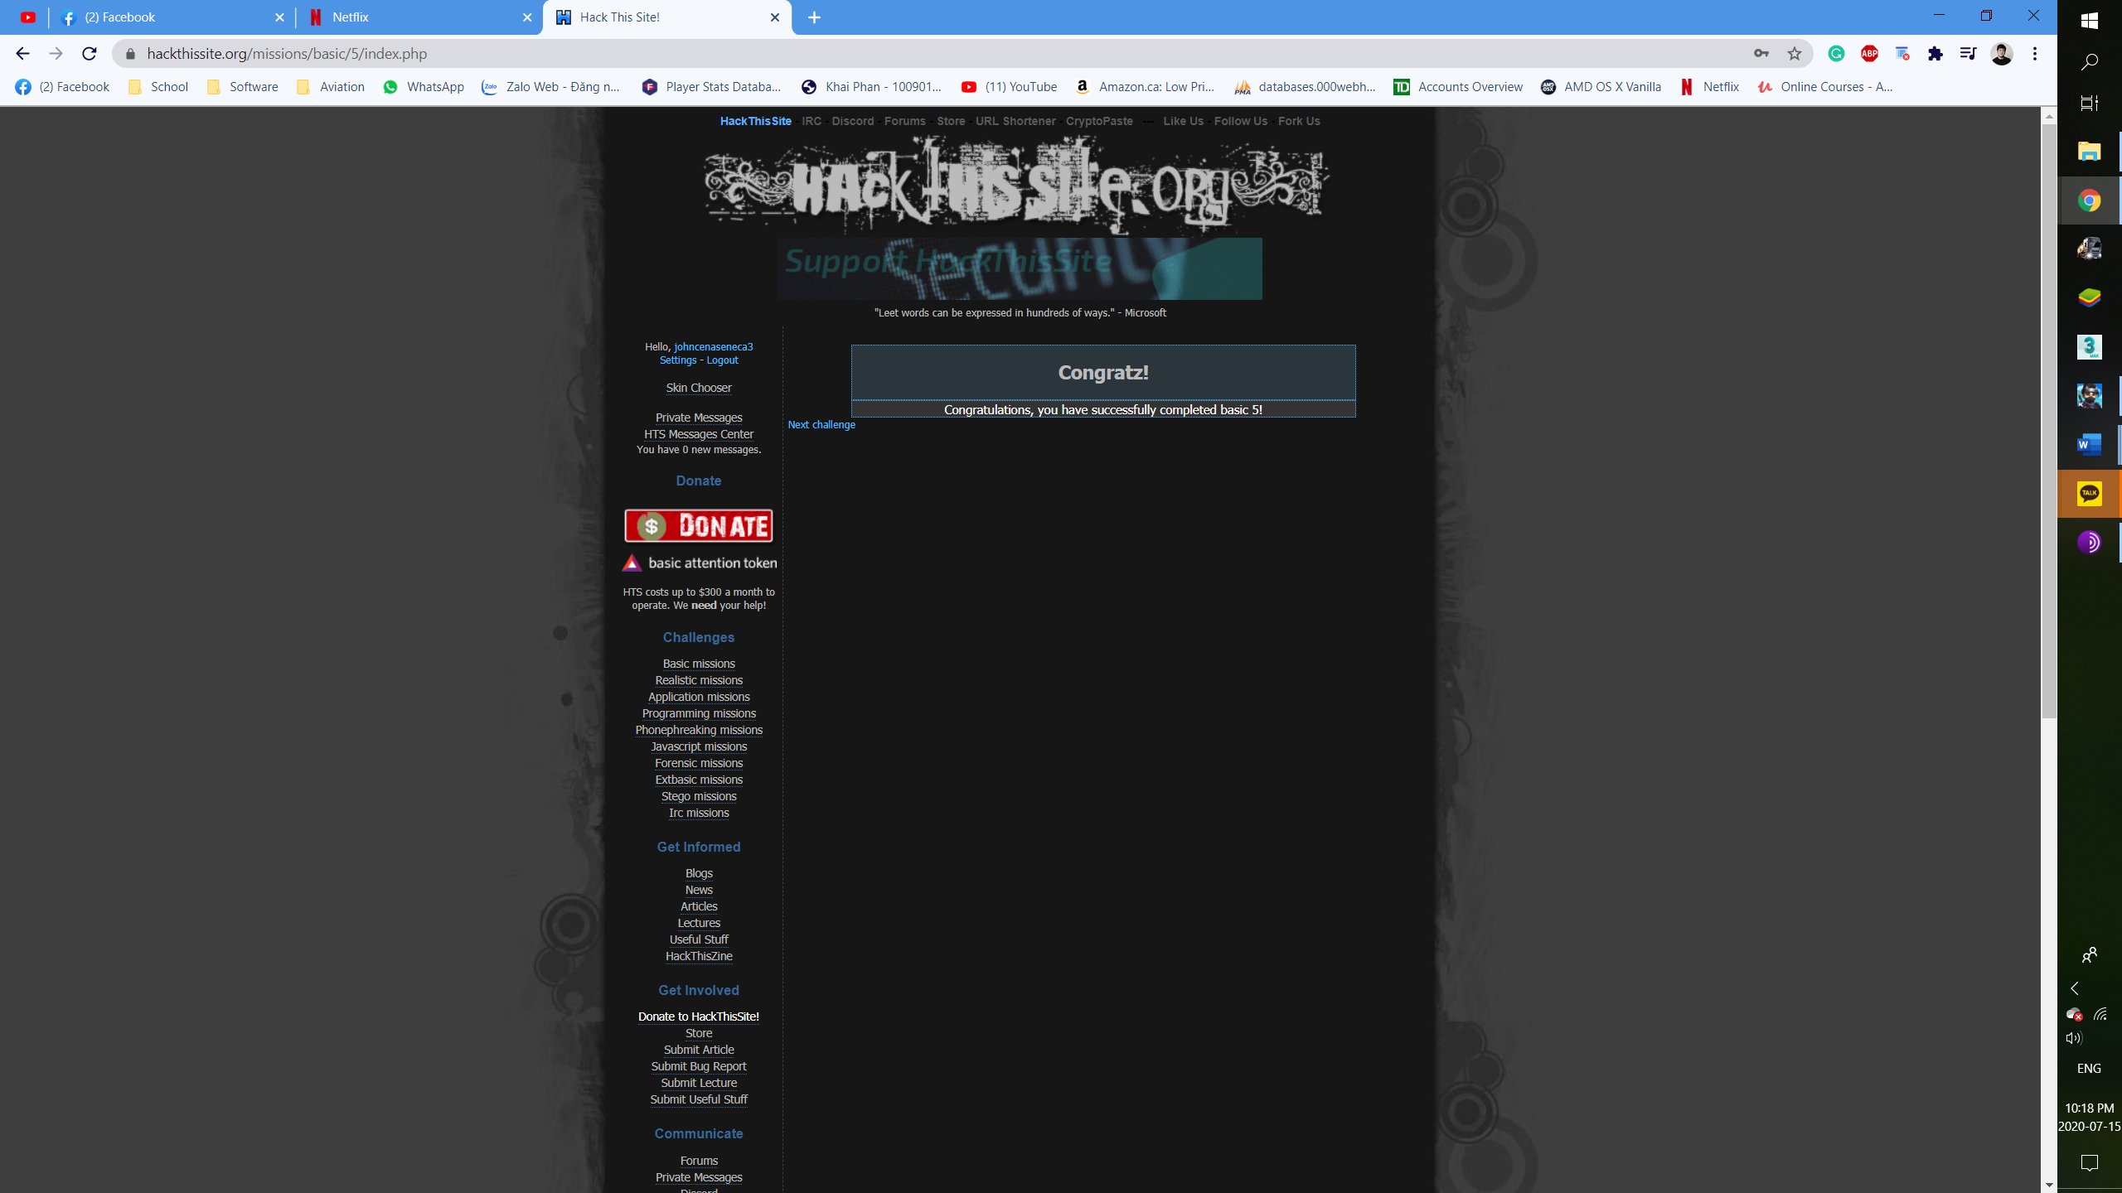

***Basic 6:***

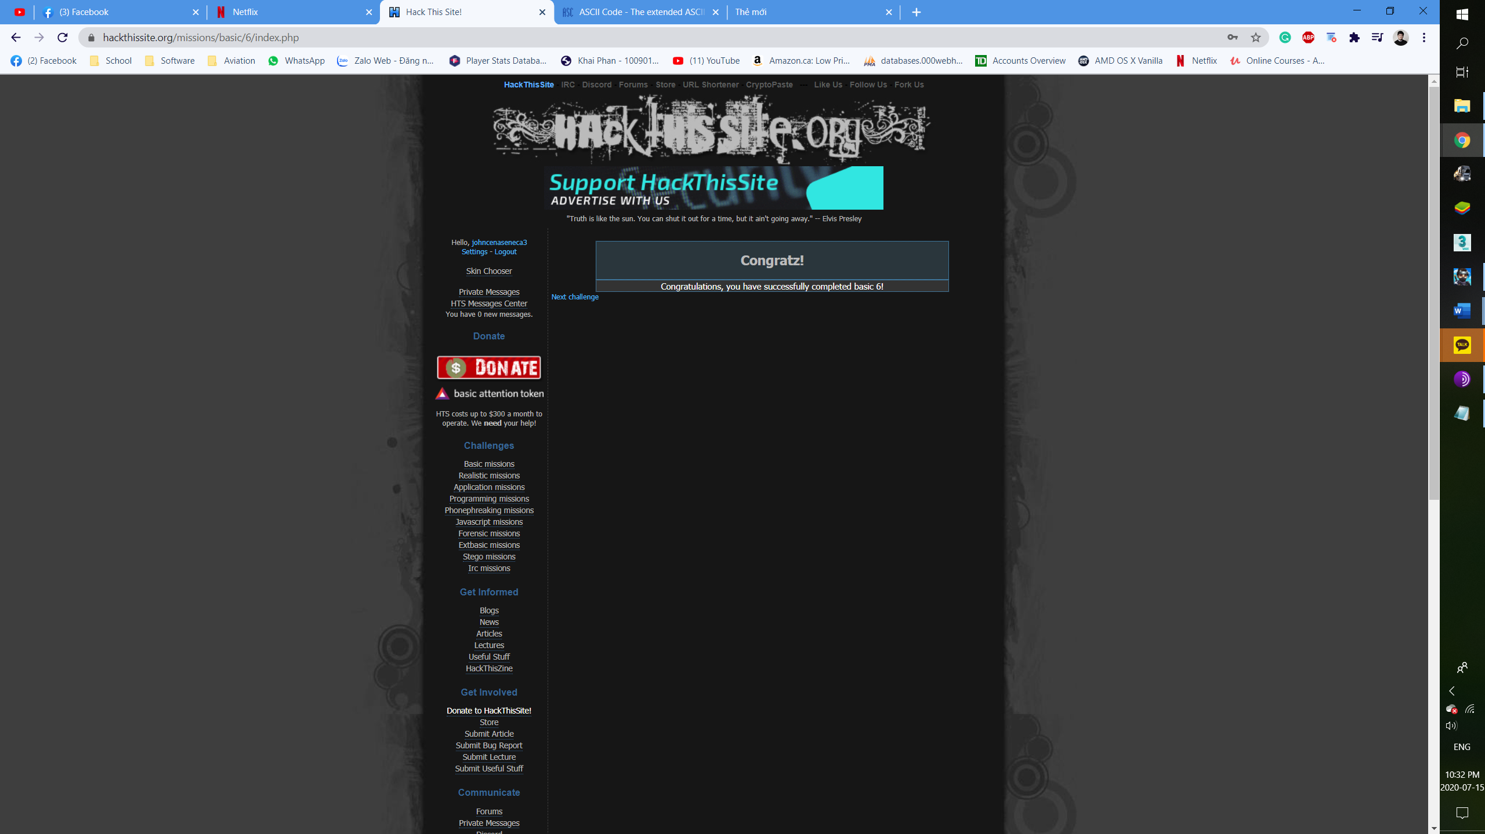

*Basic 7:*

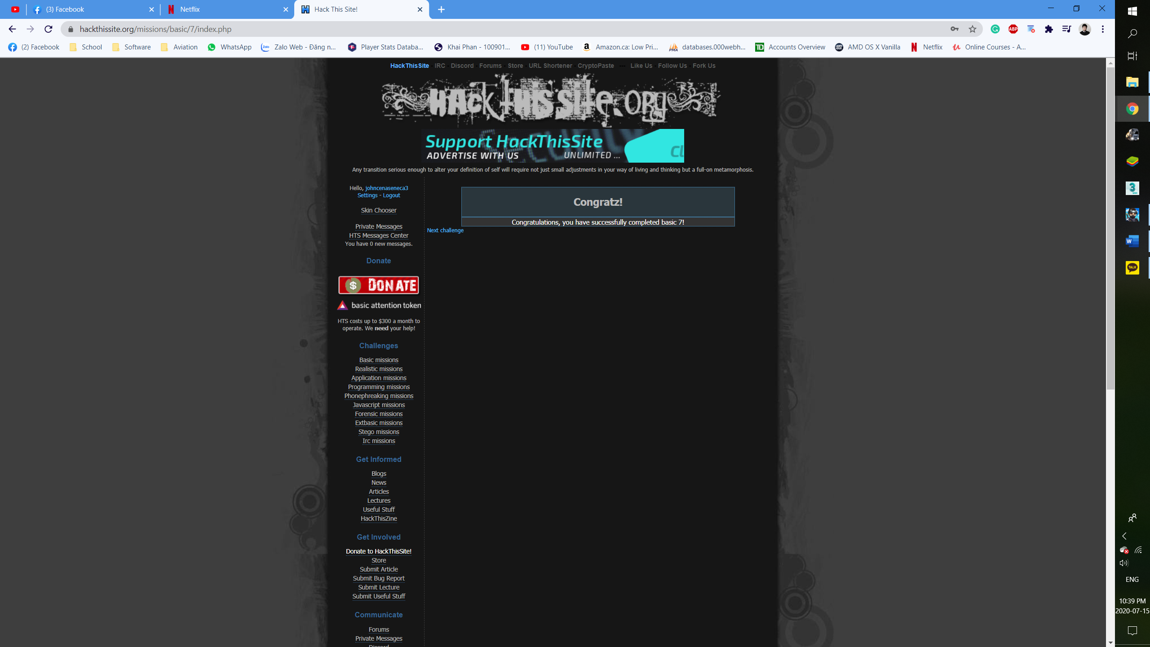

*Peace Poetry: Hacked*

